Spinning Wheel Hardware Schematics

Coin Detector Schematic
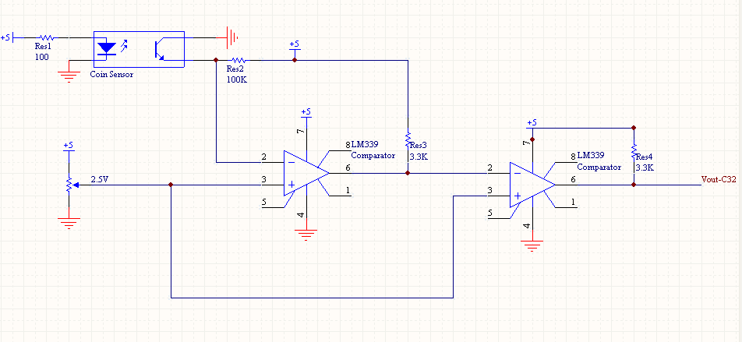

Ball Detector Schematic
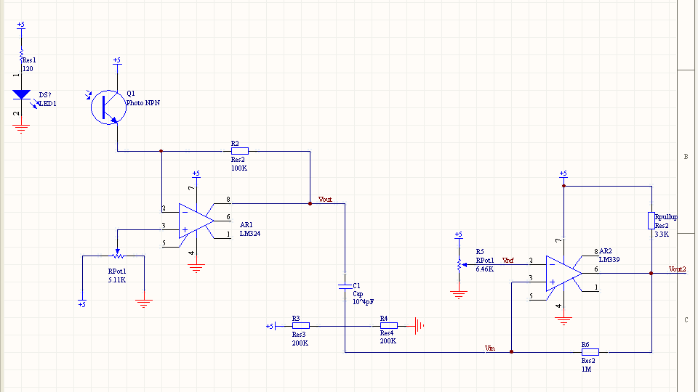

Shift Register Schematic
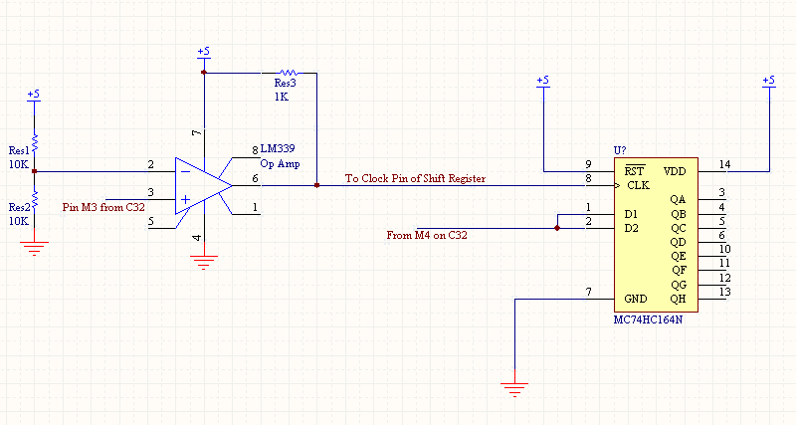

Motor Drive Schematic
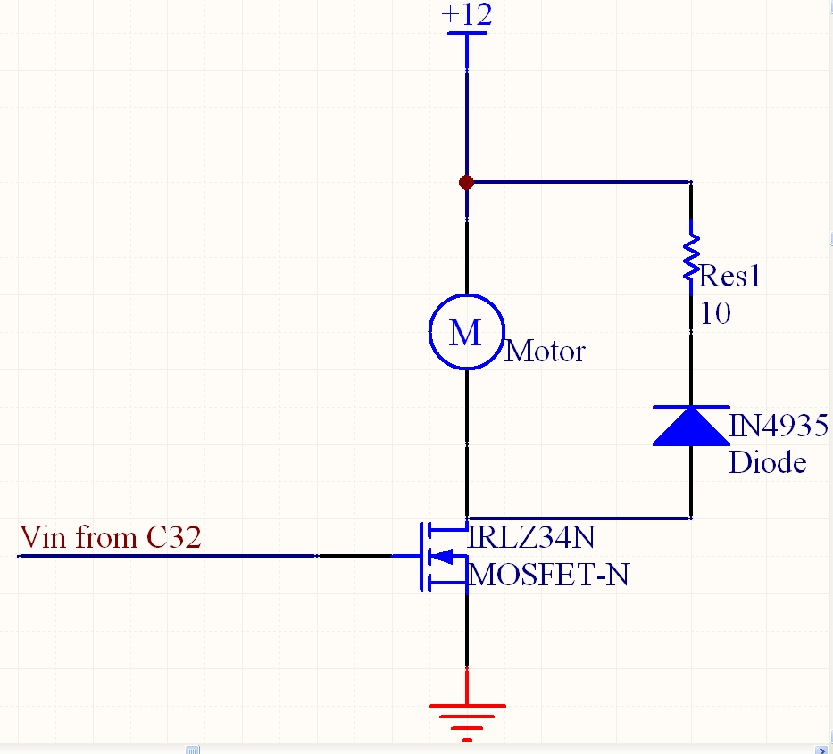

Stop Lights/Indicator Lights Schematic
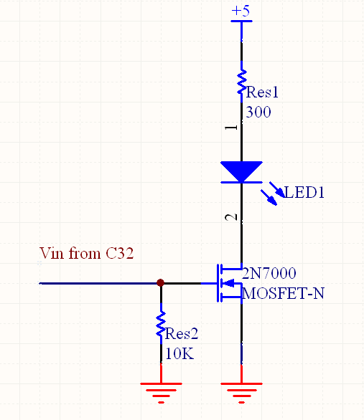

Buzzer Schematic
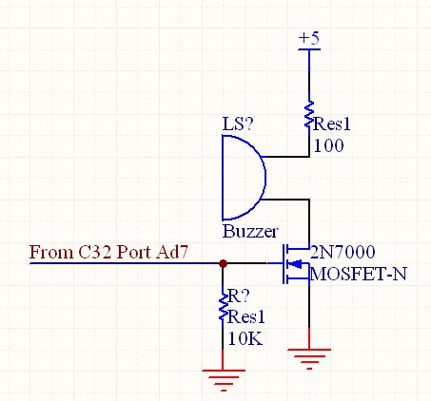

Servo Motor Drive Schematic


