Communications Protocol
ME218C

The Terman Pond Flotilla
Rev E

Communications Committee
Wednesday, the 7th of May 2008

Revision History

5/06/2008 | A | Initial Release | S.Lue & Chinghu Ju
5/07/2008 | B | B draft – Header byte, acknowledgement commands, and admiral ping added. Stand down procedure clarified. Checksum calculation fixed. Sections rearranged for clarity.
5/08/2008 | C | Family Byte from iButton, blue team terminology, Admiral addresses and bit length, data field length, “help” typo | L. Fullerton, A. Askin, S. Lue
5/12/08 | D | Commands from Watercraft to Helm Byte 2 column corrected and 0x01 Byte 0 relabeled | A. Askin
5/14/08 | E | Byte 0 on MATCHED command corrected in the table to match page 11 | A. Askin
5/17/08 | F | Typo in Admiral Helm hardware address on page 10. Admiral Helm address is 0xBCFF, not 0xAFFF | S.Lue

Table of Contents
Revision History 2
Table of Contents 3
Communications Overview 4
State Diagrams 6
Craft 6
Helm 7
ME218C Data Structure 8
Header Byte: “ME218C Byte 0” 8
iButton Commands 8
Navigation Commands 8
Navigation Byte 8
Special Actions Byte 9
Admiral Messages 10
Craft to Helm Commands 11
Ping Response 11
Acknowledgement Messages 11
XBee Radio Frame 12
Standard Message Byte Table: 12
XBee Radio Sent Packet Diagram 13
Table of Commands 14

Communications Overview
Pairing
When powered up, the helms and craft enter a ‘waiting for iButton’ state. Once a helm detects an iButton, the serial number is read and the helm enters the ‘waiting for sync’ state. Once in this state, the helm attempts to sync with a craft by repeatedly broadcasting an IBUTTON message containing the identity of the read iButton. Similarly, crafts also power up into a ‘waiting for iButton’ state. Once a craft reads an iButton, it transitions to a ‘waiting for sync’ state in which it monitors all broadcast messages sent by the helms.

When a craft receives an IBUTTON broadcast message, it checks the iButton identification data. If this data matches the iButton read by the craft, it transitions into the ‘game’ state. During this transition, the craft stores the address of the helm that sent the message and sends a MATCHED message in response to the helm. This message informs the helm which craft it is controlling for the remainder of the round. In the future, the helm may only send commands to that particular craft and the craft must only respond to commands from that helm and the admirals.

Pre-Game Operation
After successfully pairing, both the helm and craft should check the serial number from the iButton and display their team affiliation (odd serial numbers are for red team and even serial numbers are for blue teams). While this display could be performed immediately upon receiving an iButton serial number, it should be activated only when the craft has successfully paired with its helm. This display will indicate not only affiliation, but also, a successful pairing. Furthermore, after pairing, the helm must indicate to the helmsperson the number of the craft it is controlling.

The helm should at this point transition to a ‘wait for game’ state. While in this state the helm should send NO_ACTION commands at a rate of 5Hz in order to maintain the RF link with the craft and prevent it from moving. Meanwhile, the craft will transition to a ‘game’ state.

Helms remain in the ‘waiting for game’ state until the admirals broadcast the START_OF_GAME command. Once this command is issued, the game begins and helms may commence sending COMMAND signals to craft. Each COMMAND signal indicates the desired speed, direction, water delivery status (on/off), and all other special commands (see table of commands for more details). Admirals must then transmit a RED/BLUE_GOAL command to specify which goal is active.

Admiral Commands
During the game, admirals may send STAND_DOWN or HARD / SOFT_RESET commands directly to any craft. When a STAND_DOWN command is received, the craft must cease all activity and pass this command along to the helm. It is encouraged, but not required, that the craft also visibly communicate that it is disabled to observers of the match. The craft must take no action other than retransmitting STAND_DOWN_RECEIVED to the helm until the helm acknowledges the transmission. Once the helm receives and acknowledges the STAND_DOWN_RECEIVED command, it should send NO_ACTION commands until the stand down period expires (10 seconds) and display that the craft has been stood down to the helmsperson.

When a craft receives a HARD_RESET command from the Admiral, it must stop what it is doing, reset its team association, disassociate from its helm, and return to the initial ‘waiting for iButton’ state. A SOFT_RESET command is similar to a HARD_RESET command except that the craft remains in the ‘game’ state and does not disassociate from its paired helm. In other words, after receiving a SOFT_RESET command, the craft shut off all actuators, water, and special abilities then listens for new commands from its previously paired helm.

Admirals may also broadcast a RED/BLUE_GOAL broadcast command to all helms/craft. Upon, receiving this command, all helms must indicate the active base and players must move their craft to the proper side of the playfield, or be subject to a STAND_DOWN command.

Admirals may also PING craft or helms in order to determine the state and pairing of each craft/helm. Upon receiving a PING command, crafts and helms must respond with their state and pairing.

At the end of the game, the admirals will issue an END_GAME command. Upon receiving this command, helms will cease all water delivery and may only send motion commands directing craft back to the starting area. After all craft have returned, the admiralty will broadcast a HARD_RESET command to all craft and helms in order to break all helm/craft pairings. Helms and craft should both respond to this command by disassociating from their paired craft/helm, resetting all visible team/craft affiliations, and returning to the ‘waiting for iButton’ state.

Communications Failure
If, at any time, the helm and craft fall out of communication (no packets are received by the craft) for a period of greater than three seconds, the craft must turn off all actuators, water, and special functions. This is to prevent damage from and to the uncontrolled craft. Unless a HARD_RESET command is issued, the craft should continue to listen for commands from the helm. Control of the craft should resume as normal once communications are reestablished (possibly by bringing the helm into the receiving range of the craft).

State Diagrams

Craft
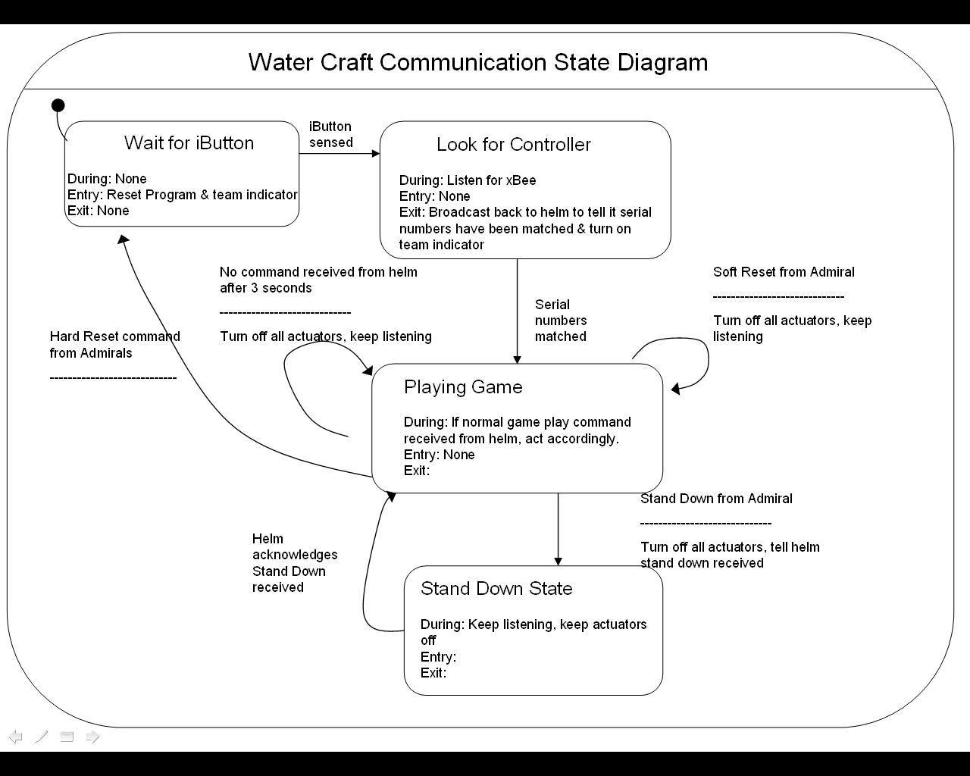

Helm
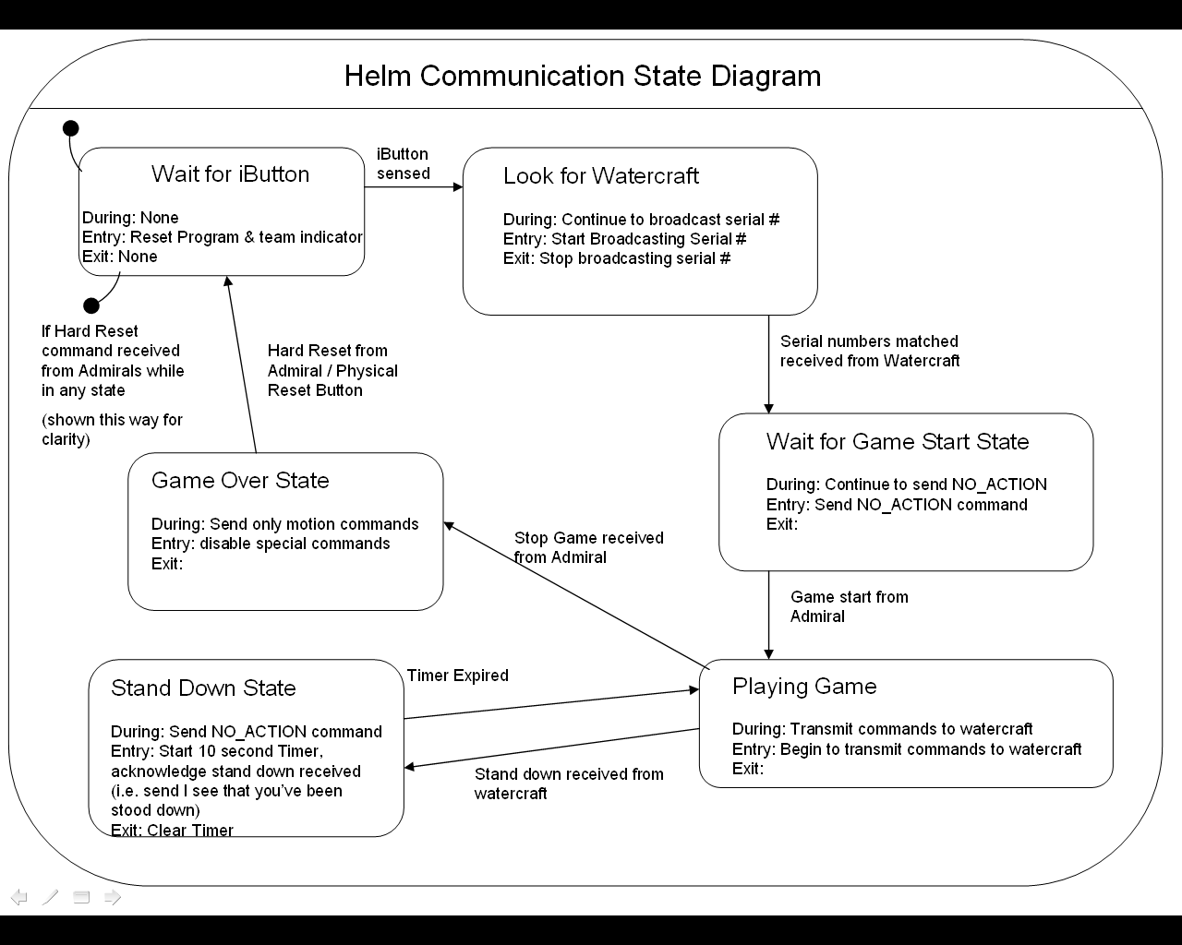

ME218C Data Structure

ME218 data is sent in three bytes. The first byte is always a header byte identifying the type of message. The last two bytes are interpreted differently depending on message type.

Header Byte: “ME218C Byte 0”
All transmissions will contain a byte to identify the type of data command being sent.
Header Translation
0x01 I-Button
0x02 Navigation (from helm)
0x04 Admiral
0x08 Water craft to helm
0x10 Ping response
0x80 Acknowledgement

iButton Commands

The iButton commands consist of the iButton header and last two bytes of the iButton serial number. Helms broadcast this command after reading an iButton. Odd iButton numbers correspond to red team, even iButton numbers correspond to blue teams.

Navigation Commands

During the game the helms send commands to the craft. These commands are structured in a navigation byte and a special actions byte.

Navigation Byte
ME218C byte 1 represents the navigation command. The navigation command is divided into two nibbles, or 4 bit data segments. The first nibble is the speed command, and the second is the direction command.
The purpose of providing speed and direction commands in 4 bits is to permit navigation using a resolution of 16. Helm controllers will communicate these commands according to the rules below:

NAV
R/W - 1 | R/W - 0 | R/W - 0 | R/W - 0 | R/W - 1 | R/W - 0 | R/W - 0 | R/W - 0
DIR3 | DIR2 | DIR1 | DIR0 | SPD3 | SPD2 | SPD1 | SPD0
bit 7 |  |  |  |  |  |  | bit 0

Direction Nibble
0x0* | Full Left
0x1* - 0x7* | Variable Left turns (~88% - ~12% left turn)
0x8* | Straight, all ahead! (0% turn) | Default
0x9* - 0xE* | Variable Right turns (~12% - ~88% right turn)
0xF* | Full Right (100% right turn)
Speed Nibble
0x*0 | Full Reverse (100% power)
0x*1 - 0x*7 | Variable reverse (~88% - ~12% power)
0x*8 | Stop (0% power) | Default
0x*9 - 0x*E | Variable forward (~12% - ~88% power)
0x*F | Full Ahead (100% power)

Example: The navigation command for all ahead full (straight at full power) is 0x8F.

Special Actions Byte
ME218C byte 2 represents the special actions command. Special actions include unique actions for each vessel, such as shooting water, making noises, etc. The description of commands may be provided to the helm by each boat.

SPAC
R/W - 1 | R/W - 0 | R/W - 0 | R/W - 0 | R/W - 0 | R/W - 0 | R/W - 0 | R/W - 0
 |  | SP1 | SP0 | WAT3 | WAT2 | WAT1 | WAT0
bit 7 |  |  |  |  |  |  | bit 0

SP0: Special Action 2
1 – Special action 2 on
0 – Special action 2 off

SP1: Special Action 1
1 – Special action 1 on
0 – Special action 1 off

WAT0-WAT3:Water Delivery
0x0 – Water delivery off
Non-zero – Variable level of water delivery 0xF is full power

Admiral Messages

Admiral commands will be designated by the sender hardware address 0xBCFF as well as the admiral header byte. The data format will be two bytes. The first byte is unused (with a 0x00 default setting); the second byte contains admiral commands via 8 active bits. Note that this will not cause any special functions to trigger because watercrafts must check the sender address while processing data packets sent by the admiral.

Admiral Commands
PING | HRST | SRST | RBA | BBA | EOG | SOG | SD
bit 7 |  |  |  |  |  |  | bit 0

There are 8 possible admiral commands. Admiral commands are addressed either to individual boats as noted below or broadcast to all recipients. In the broadcast case, the helms are responsible for interpreting the signal.

- STAND_DOWN 0x01
  - Issued to a specific boat address. Orders boat to stop all motion, water, and special abilities and forward STAND_DOWN_RECIEVED to helm. The craft must ignore all helm commands until it receives an acknowledgement transmission from the STAND_DOWN_RECEIVED transmission.
- START_GAME 0x02
  - Broadcast to all recipients. This command enables the helms to begin sending commands other than NO_ACTIONs.
- END_GAME 0x04
  - Broadcast to all recipients. Interpreted by the helm to disable all boat functions other than speed and direction.
- BLUE_GOAL 0x08
  - Broadcast to all recipients. Indicates that the blue base is active
- RED_GOAL 0x10
  - Broadcast to all recipients. Indicates that the red base is active
- SOFT_RESET 0x20
  - Broadcast to a specific boat address. Causes the boat to stop all actuators and return to the “wait for commands” state
- HARD_RESET 0x40
  - Broadcast to a specific boat address. Causes the boat to stop all actuators and return to the “waiting for iButton” state
- PING 0x80
  - Admirals send this command to crafts and helms to determine the current pairing state of the devices. When a craft or helm is pinged it must respond with a status message defined in the ping response section below.

Craft to Helm Commands

Before and during gameplay, the craft must send MATCHED and STAND_DOWN_RECIEVED commands to the helm. All commands have 0x08 as Byte 0.
- MATCHED 0x0001
  - The craft sends this command after it receives an iButton broadcast with a serial number matching the number it read off the iButton. This command should be sent to the helm that sent the matching iButton serial number
- STAND_DOWN_RECIEVED 0x0002
  - The craft sends this command to its helm after receiving and acknowledging a STAND_DOWN command from an admiral. The craft must stop all actuation, water, and special commands until the helm acknowledges this command. After acknowledgement, the craft returns to normal operation but the helm must send NO_ACTION commands for a period of ten seconds.

Ping Response

When a craft or helm is pinged by an admiral, it must respond with a message:
Byte 0: 0x10 (ping response header)
Byte 1:
- 0x01 if waiting for iButton
- 0x02 if iButton read and waiting for pairing
- 0x04 if paired
Byte 2: Least Significant Byte of paired helm/craft address (send 0x00 if unpaired)

Acknowledgement Messages

Certain transmissions require that the receiver send an acknowledgement message back to the original sender to ensure that the transmission was not lost. Acknowledgement messages simply send back the original message, except the header byte (byte 0) is changed to 0x80.
Messages requiring an acknowledgement response are:
- START_GAME - From admiral, helm responds
- END_GAME - From admiral, helm responds
- STAND_DOWN - From admiral, craft responds
- SOFT_RESET - From admiral, craft responds
- STAND_DOWN_RECEIVED – From craft, helm responds

XBee Radio Frame

A standard Xbee packet of data is composed of 4 parts (in sequence):
Part: Size:
- Start Delimiter 1 byte
- Length of frame 2 bytes
- Frame Data 7 bytes
- Checksum 1 byte

The Frame Data section is divided into two separate parts:
Part: Size:
- API identifier 1 byte
- Command Data 6 Bytes

The Command Data is where data is inserted. This is further broken down into 4 parts:
Part: Size:
- Frame ID 1 byte
- Destination Address 2 bytes
- Options 1 byte
- RF Data (User’s transmitted data) 3 bytes

In general, RF Data can be up to 100 bytes long, but in our case, the RF data is only 3 bytes long. Thus, ME218C users’ transmitted data resides in bytes 9 through 11 of each message. Byte 9 contains the Header, byte 10 is navigation, and byte 11 contains special commands.

Standard Message Byte Table:
Byte Number: Description: Value:
Byte 1) Start Delimiter 0x7E
Byte 2) Length MSB 0x00
Byte 3) Length LSB 0x08
Byte 4) API identifier 0x81 for received transmission
0x01 for transmit request
Byte 5) Frame ID Reference Number
Byte 6) Destination MSB Address
Byte 7) Destination LSB Address
Byte 8) Options See xBee Doc
Byte 9) Header Byte (Byte 0) See ME218C Data
Byte 10) Navigation Byte (Byte 1) See ME218C Data
Byte 11) Special Byte (Byte 2) See ME218C Data
Byte 12) Check Sum See below

Checksum: Not including frame delimiters and length, add up all bytes keeping only the lowest 8 bits of the result and subtract from 0xFF.

XBee Radio Sent Packet Diagram
The diagram below shows how the XBee radio packet is structured, and where within the XBee frame transmitted data resides. Note that the some of the XBee commands will change depending on whether it’s sent/received packet, but the structure remains the same. All communications will be made at 9600 baud.

0x7E
MSB
LSB
API structure
CheckSum
Start Byte
Length (2 bytes)
Frame Data (7 bytes)
1 Byte
API command
(1 byte)
Command Data (7 bytes)
Frame ID
Options byte
0x00 to enable ACK
Destination Address
MSB, then LSB
User’s Data
Byte 0
User’s Data
Byte 1
Byte 8
Bytes # 6 and 7
Byte # 5
Bytes # 9- 11
User’s Data
Byte 2

Table of Commands
Commands from Helm to Watercraft | Byte 0 | Byte 1 | Byte 2 | Respond with Acknowledgement command?
NO_ACTION | 0x02 (Navigation) | 0x88 (Navigation Byte) | 0x00 (Special Actions Byte) | NO
COMMAND | 0x02 (Navigation) | see commands section above for possible combinations | see commands section above for possible combinations | NO
IBUTTON | 0x01 (iButton) | Serial number second to least significant byte* | Serial number least significant byte* | NO (MATCHED command sent in response)
Do not send family byte (first 8 bits read from iButton) send the two bytes read after that
Commands from Watercraft to Helm | Byte 0 | Byte 1 | Byte 2 | Respond with Acknowledgement command?
STAND_DOWN_RECEIVED | 0x08 (Craft) | 0x00 | 0x02 | YES
MATCHED | 0x08 (Craft) | 0x00 | 0x01 | NO
Commands from Admiral to Watercraft | Byte 0 | Byte 1 | Byte 2 | Respond with Acknowledgement command?
STAND_DOWN | 0x04 (Admiral) | 0x00 | 0x01 | YES
HARD_RESET | 0x04 (Admiral) | 0x00 | 0x40 | NO
PING | 0x04 (Admiral) | 0x00 | 0x80 | NO (Send ping response)
SOFT_RESET | 0x04 (Admiral) | 0x00 | 0x20 | YES
Commands from Admiral to Helm | Byte 0 | Byte 1 | Byte 2 | Respond with Acknowledgement command?
START_GAME | 0x04 (Admiral) | 0x00 | 0x02 | YES
END_GAME | 0x04 (Admiral) | 0x00 | 0x04 | YES
BLUE_GOAL | 0x04 (Admiral) | 0x00 | 0x08 | NO
RED_GOAL | 0x04 (Admiral) | 0x00 | 0x10 | NO
HARD_RESET | 0x04 (Admiral) | 0x00 | 0x40 | NO
PING | 0x04 (Admiral) | 0x00 | 0x80 | NO (Send ping response)

